

**FOR PARTNERS**

**ESET   
Healthcheck service**

**Author:** Ervin Rendek

**Version:** 1.4

**Date:** May 5th, 2021

**Classification:** For Partners

Service bulletin

# Table of contents

INTRODUCTION 2

Service description 3

100 words 3

50 words 3

25 words 3

Tagline 3

Positioning 4

Target market and buyers 4

Market statistics 4

Market problems 5

Solutions 6

What is new in ESET Professional Services 7

1. Including Partners into the service delivery process 7

2. Tier 1 and Tier 2 covered by Partner, Tier 3 covered by ESET HQ 7

3. Comprehensive training plans for Partners’ staff 8

Prerequisites and conditions for ESET Healthcheck 9

Responsibilities in the service delivery model 10

List of products eligible for ESET Healthcheck 12

Human resources requirements for successful delivery 13

# INTRODUCTION

In today’s competitive cybersecurity landscape, buyers are increasingly making their choices based not only on the available products but on the services which make up the overall solution. By evaluating services first, and choosing products that have a strong supporting ecosystem, customers can rest assured that they will be able to reap a product’s full benefits – even if something goes wrong or they themselves are not able to cover all the bases.

This trend for choosing complete solutions, instead of just standalone products, has been heralded and documented by industry analysts to quite a wide extent. As such, it is clear that vendors must be able to provide services that match their products in order to remain relevant and maintain an edge over their competitors.

ESET products are sold worldwide. More than 50% of our revenue comes from the business licenses. Business customers often demand not only a high-quality product, but also supporting services. And these customers are often willing to pay more for such services. At ESET, we are more than ready to provide our customers with outstanding services that result in quick and satisfactory resolution of issues that might occasionally result from using our complex products. If such issues occur, it is often necessary to resolve them as soon as possible in order to mitigate the impacts on business continuity or IT security. Enterprise customers often ask for deployment services and consider these to be a true starting point in utilizing their security solution. Subsequently, healthcheck is a service frequently asked for by Enterprise-grade customers that want to thoroughly examine the settings of their ESET product environments and receive recommendations for optimization.

ESET Healthcheck is a crucial element in our Professional Services family. As the name suggests, the aim of this service is for ESET professionals to scrutinize customer’s ESET business product environments and suggest ways to improve their operation and maximize the potential of the ESET products in place. Tailored recommendations that are given by ESET professionals (as an outcome of the provision of the service) will always state how to achieve a more effective configuration of ESET products, with a special focus on the specifics relevant to customer in question.

ESET Healthcheck is, in the ideal scenario, preceded by execution of another Professional Service – ESET Deployment & Upgrade (see service bulletin for ESET Deployment & Upgrade). When it comes to Deployment, optimal functioning of ESET business products is achieved by their correct installation and initial configuration of newly purchased by ESET experienced and certified professionals, either via remote connection to the customer’s network or visiting the customer on-site. Healthcheck is ideally executed later in the license lifecycle (e.g. after three months of license validity) in order to verify how effectively the product was initially set up and how effectively the customer has altered the initial settings. Of course, an output of the ESET Healthcheck service is to suggest optimization of ESET product settings after they have been in operation for some time.

However, if the customer insists on deploying ESET business products on their own, the ESET Healthcheck service might serve as a “verification“ of correct deployment and set-up. In such cases, we advise customers to consider purchasing the ESET Healthcheck service and having it executed either immediately after deployment of after a reasonable amount of time (e.g. three months), when doubts about the correctness of configuration arise.

# Service description

## 100 words

ESET Healthcheck service offers a thorough inspection of a customer’s ESET products environment at a reasonable point after it is put into operation. Starting with an overall examination of ESET product integration within the whole IT environment, continuing with scrutiny of product configurations and settings, and finishing with a comprehensive document containing valuable advice on possible improvements, our Healthcheck service helps customers reach optimal operation of ESET products and ensure business continuity. Recommendations received as a result of a Healthcheck will positively improve the customer’s ROI by pointing out potential performance improvements in day-to-day administrator business operations.

## 50 words

ESET Healthcheck service offers a thorough inspection of a customer’s ESET products environment focusing on correct and effective configuration. Recommendations received as a result of the delivery of the service will demonstrate ways to optimize the use of ESET products, but will also identify potentially useful tips for administrators.

## 25 words

ESET Healthcheck service examines your ESET business products policies, settings and configurations, identifies areas for improvement and suggests action points.

## Tagline

ESET Healthcheck examines your ESET business products configurations and suggests improvements.

# Positioning

As described above, services and provision of complete solutions are a clear market trend, but it is important to position the ESET Healthcheck service correctly and understand all its benefits when communicating with customers.

To be able to address the growing landscape of cybersecurity threats, organizations are forced to adopt more advanced tools and policies which further increase the overall complexity of their business. Rapidly emerging threats and attack techniques are a concern that can easily distract workforces and the general lack of security specialists creates a gap that can be filled by cybersecurity vendors, system integrators and MSSPs. In an attempt to reduce overall complexity and ensure business continuity, organizations turn to complete solution providers and expect such services even from their current security vendors.

## Target market and buyers

Enterprise grade customers (1000+ seats), and customers with complex environments (subject to Healthcheck team resource manager approval), governments and related institutions. In general, organizations that face the challenges listed below.

## Market statistics

* In 2019, around 9% percent of a whole security budget of an average company went to Managed Security Services. (Source: Forrester, Security Budgets Europe, 2020: New Threats Bring New Priorities)
* There is a clear shift from spending on products towards spending on services. The most dramatic shift towards services spending is observable with companies that spend up to 10 percent of their overall IT budget on security, whose spending on services rose from 47% in 2017 to 56% in 2019. (Source: Forrester, Security Budgets Europe, 2020: New Threats Bring New Priorities)

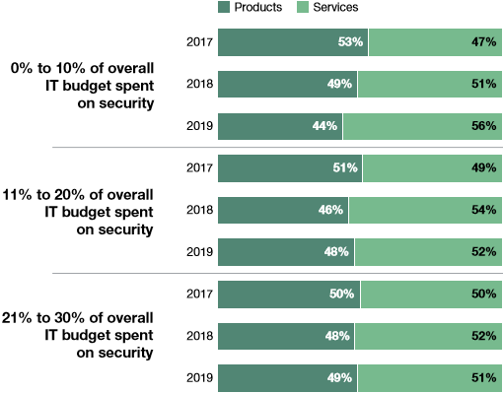

* European security leaders now spend more of their budget on services than products. Like their colleagues globally, European security leaders at Enterprises spend, on average, more than half (52%) of their budget on services related to security products versus acquiring new security products. (Source: Forrester, Security Budgets Europe, 2019: Budgets Rise And Security Services Overtake Products)
* Competition for security talent has firms exploring the security services route. Stiff competition for security talent has caused many firms to invest in services rather than in more expensive and hard-to-recruit security staff. Some 22% of global security decisionmakers cite lack of security staff as a major information security challenge, and 21% mention the difficulty of finding employees with the right skills. (Source: Forrester, Security Budgets Europe, 2020: New Threats Bring New Priorities)
* The security services market is considered to be focused on both SMB and Enterprise.

## Market problems

### Steep initial learning curve

While ESET products in general are designed to be intuitive to use, without proper training, customers could be missing out on many game-changing advanced features.

### Sub-optimal product settings

Purchasing and deploying hi-tech products unfortunately does not necessarily guarantee their proper operation. E.g. too-frequent connection intervals to console; missed reports that could be useful; database overloads, etc.

### Life with insecurities

The customer’s IT staff might not feel secure after deploying and setting up an ESET solution because of their fear about not setting up the product effectively and correctly.

### Lack of manpower

The general lack of security specialists causes an increased need for outsourcing of tasks Infrastructure complexity – adapting to rapidly evolving business needs (and cyber threats) requires frequent updates to software and hardware and therefore version and general product compatibility must be assessed by professionals.

### Preference for outsourcing

Many organizations are, in general, turning to outsourcing as a way to simplify the management of their resources.

### Business continuity

The deployment and/or upgrade of new products into live environments without the required expertise presents a serious business continuity risk.

### Long-term costs

Creating dedicated teams and/or hiring specialists to perform niche occasional tasks can incur high long-term costs.

## Solutions

All of the above challenges can easily be addressed by having a complete product and services portfolio offered across multiple regions. ESET Healthcheck addresses all of the above problems and its further benefits include:

### Verification by experts

ESET products deployed by customer staff themselves might greatly benefit from Healthcheck service provision immediately after deployment. Or ESET products deployed as a part of ESET Deployment & Upgrade service may also benefit from a Healthcheck service after a reasonable amount of time in operation.

### Recommendations that make a difference

Inefficiencies in a customer’s ESET ecosystems will be identified by ESET experts and recommendations about potential fixes/improvements will be provided as a part of a Suggestions & Recommendations Document.

### Business continuity assurance

By healthchecking products according to a precise schedule based on the outcome of an initial infrastructure assessment by our dedicated specialists, greater business continuity is assured. ESET experts’ stamp of approval for initial installation and configuration is often required by customers, especially those with customization needs (e.g. integration with in-house tools using ESET interfaces).

### Added value to our products

In addition to all of the above, providing professional services can be the deciding factor in deals and tenders.

# What is new in ESET Professional Services

Even though ESET HQ has provided Healthcheck services to our business customers in the past, we have not included our Offices and Partners (hereinafter referred to as “Partners“) into the service delivery process itself. Our Partners have mainly been responsible for the deal-closing part of the service and this has usually consisted of identifying a new sales opportunity for Healthcheck and closing the deal with the customer from an administrative perspective. ESET HQ, on the other hand, has been in charge of technical delivery of the service in the customer’s environment. To summarize, historically, the Partner’s role was to win the deal and ESET HQ would deliver the service itself.

At ESET HQ, we have this approach to the Healthcheck process and identified a couple of major improvements that would be beneficial both for Partners and for ESET HQ, from a capacity-leveraging aspect but also from a revenue-maximizing one.

## 1. Including Partners into the service delivery process

It is obvious that in recent years a great number of our Partners have invested in their employees’ technical capabilities to a very high level. It does not matter much whether we are talking about training and certification in ESET products or other relevant IT training. Both have contributed to the fact that, as of 2020, we can state that a significant portion of our Partner network is now employing highly-trained professionals who are without doubt capable of executing the Healthcheck service. Its exact processes, of course, will be outlined by ESET HQ in order to achieve Healthcheck consistency around the globe.

Including our partners in the service delivery model is beneficial for end-customers requiring on-site service delivery capabilities. And those are almost exclusively unique to local ESET representatives.

Another reason for including Partners in the technical aspect of the Healthcheck service is the limited capacity for service delivery from ESET HQ. If we are honest with ourselves, ESET HQ is currently not capable of covering Healthcheck service delivery in all countries in which we sell our products. The technical specialists based at ESET HQ and dedicated to service delivery are, capacitywise, able to deliver only tens of service deliveries a year. With regards to this fact, we feel that we are losing a big portion of revenue simply because we are currently not a service-oriented company. Therefore, including Partners’ trained staff into our service delivery model will definitely leverage the current overall resources available to both HQ and Partners. Using this deeper cooperation between HQ and Partners, we will multiply our mutual Healthcheck capacities, resulting in greater service coverage and revenue potential.

## 2. Tier 1 and Tier 2 covered by Partner, Tier 3 covered by ESET HQ

Delivery of the Healthcheck service was previously more or less a bespoke service, tailored to every single service delivery and every single customer’s situation. Since all the knowledge was possessed by ESET HQ and the numbers of service deliveries were rather small, ESET HQ could use this tailored approach.

In the course of delivering this service in the past, we have learned that categorization of partial D&U activities into tiers can help a great deal in streamlining and standardizing the service delivery process. That is of course a prerequisite for a standardized Healthcheck service offering worldwide. We have therefore divided the service delivery process into clear categories, and each category has been assigned a tier which reflects its respective complexity. Tier 1 and Tier 2 activity categories will be almost exclusively covered by Partners, since product knowledge for Tier 1 and Tier 2 is attainable via trainings and certifications. Tier 3 activity categories will be covered by ESET HQ since these activities may include aspects that closely relate to the deepest knowledge of ESET business products, often requiring access to product development engineers.

## 3. Comprehensive training plans for Partners’ staff

The new service delivery model, utilizing our Partner network to a greater extent, will definitely challenge us in terms of the consistency of the delivered service across different regions. Since our ultimate goal is to achieve the highest possible quality of the service delivery consistently, we have developed a comprehensive training plan for our Partners’ professionals who will execute the service. A separate document specifying training paths is included as a part of documentation for HealthCheck.

# Prerequisites and conditions for ESET Healthcheck

* Only previously purchased and deployed ESET products are eligible for the Healthcheck service and should be a part of the overall solution (Products + Services) provided to customers
* The customer is willing to provide supervised access to their environment and related infrastructure by the remote management tools used by ESET
* A standalone Healthcheck service may be both purchased and executed at any time within the validity of a particular business product license
* The service is primarily aimed at large Enterprise-grade customers or organizations with a complex infrastructure that warrants the costs of the service (exceptions must be discussed with HQ or the local Healthcheck team)
* An initial assessment of the customer’s current environment must be performed (by completing the Assessment Form) to confirm the feasibility of the Healthcheck proposed by sales representatives, before promising anything to the customer
* Date and schedule planning must be done in coordination with HQ if the customer exceeds 500-seat threshold
* Normally communication between the customer and Healthcheck specialists should be handled by the SPOC (single point of contact, e.g. the sales representative), unless agreed upon otherwise (e.g. for complex projects requiring the customer’s technical staff to communicate with our Healthcheck specialists)
* The final cost is calculated based on the final number of service units needed/agreed upon with the customer in order to successfully execute the service. By default the final cost of the service is equal to 1 service delivery/unit. This is confirmed by both parties (customer and Partner), prior to service execution, by the acceptance of a Healthcheck Plan.
* A Healthcheck is considered to be completed upon customer’s signature of the Suggestions & Recommendations Document by the customer

# Responsibilities in the service delivery model

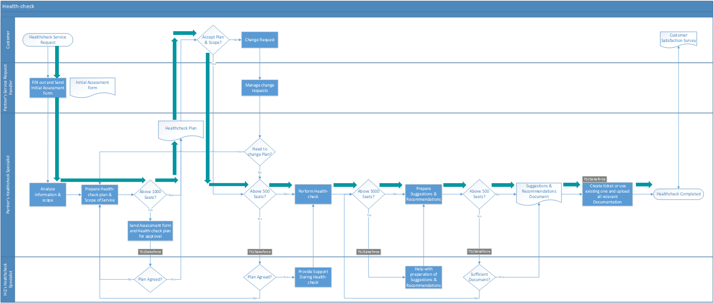

The diagram above depicts the ideal workflow for the Healthcheck service, with rows representing an “actor” or a person responsible for execution of a specific activity in the workflow. The goal of this diagram is to describe a sequence of sub-activities that lead to a successful, by-the-book delivery of this professional service. For the sake of simplicity, we will further describe the ideal workflow (indicated by green arrows) without any change requests or inconsistencies which may occur along the way. Of course, these are also fully covered by the diagram.

### Healthcheck Plan Phase

Begins with an Enterprise Customer expressing their wish for the Healthcheck service. The Partner’s Services Request Handler (hereinafter referred to as the Salesperson) fills in an Assessment form together with the Enterprise Customer and hands it over to the Partner’s Healthcheck Service Specialist (Level 1/ Level 2) (hereinafter referred to as the HSS) for evaluation. As part of the Assessment form, the HSS should very briefly familiarize themselves with the list of ESET products to be healthchecked and approximate environment schema (Server, Database, Agents, Products, etc.) of that particular customer. If, based on the Assessment form, it seems that delivery of the Healthcheck service is feasible, the HSS prepares an ESET Healthcheck Plan describing aspects like the environment schema in which ESET products are deployed, and the scope of the service. The Salesperson in turn adds info about units/deliveries to the ESET Healthcheck Plan (based on how demanding it is expected to be, but usually it is 1 service delivery), which is then sent to the Enterprise Customer for acceptance. In an ideal world the Enterprise Customer would accept the Healthcheck Plan and the HSS can then proceed to organization of a a remote session/on-site visit with the customer in order to execute the service.

### Healthcheck Execution Phase

Is pretty straightforward, with the HSS either connecting remotely to the customer’s environment or visiting them on-site. The Healthcheck service then runs according to the agreed Healthcheck Plan. After the HSS has completed the service execution, s/he disconnects from the customer’s environment and starts working on the Suggestions & Recommendations Document. This document is then presented to the customer as an outcome of the service and the HSS requests the customer’s approval. Signing of the Suggestions & Recommendations Document is a very important step and is carried out typically by the HSS in order to obtain the customer’s consent to the scope and extent of the delivered service.

### Post Healthcheck Phase

Is typically connected with finalization of the billing and invoicing (if not done earlier in the process). The HSS or Professional Services Team at HQ might ask for feedback on the executed service. If the Healthcheck service was sold to the customer as a standalone service (as opposed to an ESET Premium Support Advanced service bundle), the Post Healthcheck Phase is also a very good opportunity for upselling activities. ESET Premium Support Essential is a great service to suggest to customer in order to achieve seamless operation of their healthchecked ESET products. The Healthcheck service is a great starting point to present our capabilities to customers and can serve as a strong teaser for purchasing our other services.

The last row of the diagram above encompasses ESET HQ Product Specialist activities (Tier 3/ Level 3). In order not to place too much bureaucratic pressure on our Partners, ESET HQ gets involved only in a couple of special cases, usually depending on the size of the customer. In general, ESET HQ assists Partners in:

* agreeing to ESET Healthcheck Plans for customers bigger than 500 seats
* assisting in preparation of the ESET Suggestions & Recommendations Document
* reviewing the ESET Suggestions & Recommendations Document for customers with more than 500 seats

# List of products eligible for ESET Healthcheck

*As of May 5, 2021*

|  |  |
| --- | --- |
| ESET Cloud Office Security | ESET Full Disk Encryption |
| ESET Endpoint Antivirus for Linux | ESET Gateway Security for Linux |
| ESET Endpoint Antivirus for Mac OS X | ESET Mail Security for IBM Lotus Domino |
| ESET Endpoint Antivirus for Windows | ESET Mail Security for Linux |
| ESET Endpoint Encryption | ESET Mail Security for Microsoft Exchange Server |
| ESET Endpoint Security for Android | ESET Protect (Cloud) |
| ESET Endpoint Security for Mac OS X | ESET Secure Authentication |
| ESET Endpoint Security for Windows | ESET Security for Microsoft SharePoint |
| ESET Enterprise Inspector | ESET Security for Microsoft SharePoint Server |
| ESET File Security for Linux | ESET Virtualization Security |
| ESET File Security for Microsoft Windows Server |  |
|  |  |

Since ESET’s product portfolio is dynamic and our offering may change over time, it is strongly advised to always verify the list of products eligible for the Healthcheck service against our [End Of Life policy (EOL)](https://support.eset.com/en/kb3592-is-my-eset-product-supported-eset-end-of-life-policy-business-products). The list of products in the above table reflects our current business products offering, but to obtain fresh information regarding the supported versions, always visit our EOL website.