

**FOR PARTNERS**

**ESET Premium Support Essential**

Pilot of 2020 services offering

**Author:** Ervin Rendek

**Version:** 1.6

**Date:** Sep 30h, 2020

**Classification:** For Partners

Service bulletin

# Table of contents

INTRODUCTION 2

Service description 3

100 words 3

50 words 3

25 words 3

Tagline 3

Positioning 4

Target market and buyers 4

Market statistics 4

Market problems 5

Solutions 6

What is new in ESET Premium Support ESSENTIAL service 7

The old ESET Premium Support offering 7

The new ESET Premium Support Essential offering 7

1. Indirect delivery model 8

3. Comprehensive training plans for Partners’ staff 9

4. Tier-based pricing 9

ESET Premium Support ESSEntial vs Standard Support 10

Prerequisites and conditions for Premium Support Essential 11

Responsibilities in the service delivery model 12

List of products eligible for for ESET Premium Support essential 14

Human resources requirements for successful delivery 15

# INTRODUCTION

In today’s competitive cybersecurity landscape, buyers are increasingly making their choices based not only on the available products but on the services which make up the overall solution. By evaluating services first, and choosing products that have a strong supporting ecosystem, customers can rest assured that they will be able to reap a product’s full benefits – even if something goes wrong or they themselves are not able to cover all the bases.

This trend for choosing complete solutions, instead of just standalone products, has been heralded and documented by industry analysts to quite a wide extent. As such, it is clear that vendors must be able to provide services that match their products in order to remain relevant and maintain an edge over their competitors.

ESET products are sold worldwide. More than 50% of our revenue comes from business licenses. Business customers often demand not only a high-quality product, but also supporting services. And these customers are often willing to pay more for such services. At ESET, we are more than ready to provide our customers with outstanding services that result in quick and satisfactory resolution of issues that might occasionally result from using our complex products. If issues occur, it is often necessary to resolve them as soon as possible in order to mitigate the impacts on business continuity or IT security. Attentive customers often ask for premium support services and consider them to be an integral part of their security solution.

ESET Premium Support Essential (EPSE) is a building block of the ESET Professional Services family. Aimed at the Enterprise segment, but not excluding SMB segment customers, EPSE is a professional service that brings Enterprise administrators peace of mind and assures them that they are entitled to receive prompt assistance from their security vendor at any hour of the day or night, including weekends and public holidays. Enterprise-grade customers often anticipate this type of service from their IT system vendors, with IT security being a leading concern.

Offered either as a standalone service in addition to a product license, but also as a sub-service of the ESET Premium Support Advanced service, ESET Premium Support Essential goes hand in hand with newly purchased licenses for ESET business products.

As of mid 2020, EPSE has been already running successfully for seven years. The fact that dozens of Enterprise-grade customers have been paying extra money for this service for several years indicates that we are on the right track. Similarly, ESET HQ also runs so-called Partner Support, which provides our major offices and partners with technical support for more sophisticated technical issues connected with the support they provide to their business customers, 24/7. Both current ESET Premium Support Essential and ESET Partner Support directly involve HQ Technical Specialists, to a greater or lesser extent.

There are some exciting changes to our overall technical support model within the new Enterprise services offering for 2020, as will be explained in this service bulletin.

# Service description

## 100 words

ESET Premium Support Essential offers a guaranteed, prioritized and accelerated technical support service provided by a local and certified ESET Partner in close cooperation with ESET HQ, executed in English. The aim of this service is to troubleshoot ESET business products that are not behaving in accordance with the product manual. This service will be provided by dedicated specialist support teams working to a defined SLA in order to provide fast and detailed analysis of the problem, followed by precise troubleshooting advice (when appropriate). Compared to standard (unpaid) support, ESET response times via Premium Support Essential are much shorter, fixed and, moreover, guaranteed.

## 50 words

ESET Premium Support Essential offers a guaranteed, prioritized and accelerated technical support service provided by a local and certified ESET Partner in close cooperation with ESET HQ, executed in English. The aim of this service is to troubleshoot ESET business products that are not behaving in accordance with the product manual.

## 25 words

ESET Premium Support Essential represents a guaranteed, prioritized and accelerated product support service provided by a certified ESET Partner in cooperation with ESET HQ.

## Tagline

ESET Premium Support Essential quickly resolves technical issues with your ESET products.

# Positioning

As mentioned earlier, services and the offering of complete solutions are a clear market trend. Nevertheless, it is important to position the ESET Premium Support Essential service correctly and understand all of its benefits when communicating with customers.

To be able to address the growing landscape of cybersecurity threats, organizations are forced to adopt more advanced tools and policies which further increase the overall complexity of their business. Rapidly emerging threats and attack techniques are a concern that can easily distract workforces, and the general lack of security specialists creates a gap that can be filled by cybersecurity vendors, systems integrators and MSSPs. In an attempt to reduce overall complexity and ensure business continuity, organizations turn to complete solution providers and expect such services even from their current security vendors.

## Target market and buyers

Enterprise grade customers (1000+ seats), SMBs and customers with complex environments (subject to EPSE resource manager approval), governments and related institutions. In general, organizations that face the challenges listed below.

## Market statistics

In 2019, around 9% of the whole security budget of the average company went on managed security services. (Source: Forrester, Security Budgets Europe, 2020: New Threats Bring New Priorities)

There is a clear shift from spending on products towards spending on services. The most dramatic shift towards services spending is observable with companies that spend up to 10 percent of their overall IT budget on security (rising from 47% on services in 2017 to 56% in 2019). (Source: Forrester, Security Budgets Europe, 2020: New Threats Bring New Priorities)

European security leaders now spend more of their budget on services than products. Like their colleagues globally, European security leaders at Enterprises spend, on average, more than half (52%) of their budget on services related to security products versus acquiring new security products. (Source: Forrester, Security Budgets Europe, 2019: Budgets Rise And Security Services Overtake Products)

Competition for IT security talent has led firms to explore the security services route. Stiff competition for talent has caused many firms to invest in services rather than in more expensive and hard-to-recruit security staff. Some 22% of global security decisionmakers cite lack of security staff as a major information security challenge, and 21% mention the difficulty of finding employees with the right skills. (Source: Forrester, Security Budgets Europe, 2020: New Threats Bring New Priorities)

The security services market is considered to be focused on both SMB and Enterprise.

## Market problems

### Long resolution times

Even though software usually comes with standard product support, service levels are almost never guaranteed and vendors support their standard customers on a best-effort basis. Due to the fact that reported cases wait in a “ticket queue”, this often leads to long response times and even longer resolution times.

### The customer is just a number

Enterprise-grade customers in particular tend to be very complex. Vendors often do not really understand the needs of these customers, nor know their infrastructure and environment.

### Business continuity in danger

While our products are, in general, designed to be intuitive and have comprehensive accompanying documentation, particular product settings can still be misunderstood by admins – which may prevent them from executing vital operations.

### Malfunction in the customer’s environment

Purchasing and deploying hi-tech products unfortunately does not necessarily guarantee their seamless operation. Specific combinations of OS, HW and SW may cause unexpected behaviors.

### Product bugs

However comprehensive their quality assurance process, no vendor releases software products that are 100% bug-free.

### Customized IT infrastructure

Enterprise-grade customers often deploy their products to different sites in different locations, often using already crowded infrastructure. This may cause unforeseen clashes and incompatibilities which require quick and tailored actions.

## Solutions

ESET Premium Support Essential addresses all of the above problems and, as part of the ESET Premium Support Advanced service, provides an ultimate product-service solution, ranging from Deployment, Healthcheck, Upgrade and constant Premium Support.

All of the above challenges can easily be addressed by purchasing EPSE:

### Fast and guaranteed response

### Knowing our Enterprise customers

Especially within the ESET Premium Support Advanced, ESET really gets to know its customer because we take care of the complete lifecycle of the product, with the specifics of the customer’s environment in mind.

### Business continuity assurance

### Investigation of malfunctions with a focus on the customer’s environment

### Prioritized access of EPSE customers to development teams.

What normally takes days, EPSE speeds up rapidly. With strictly fixed SLAs, tickets requiring development investigation reach our development teams in no time.

### Added value to our products

In addition to all of the above, providing professional services can be the deciding factor in deals and tenders.

### Local partner care

Moreover, a local ESET presence enables a very local approach and, combined with ESET HQ’s technical expertise, results in the best possible ESET experience.

# What is new in ESET Premium Support Essential service

## The old ESET Premium Support offering

ESET products have historically been sold via our network *of regional offices, partners or authorized distributors (hereinafter ‘Partners’)*. In the old EPSE model, Partners were typically responsible for covering the business aspect of services, mainly consisting of winning the deal and handling the business and legal paperwork exchange between ESET and the customer. Partners never participated in service delivery itself: this was covered by ESET HQ.

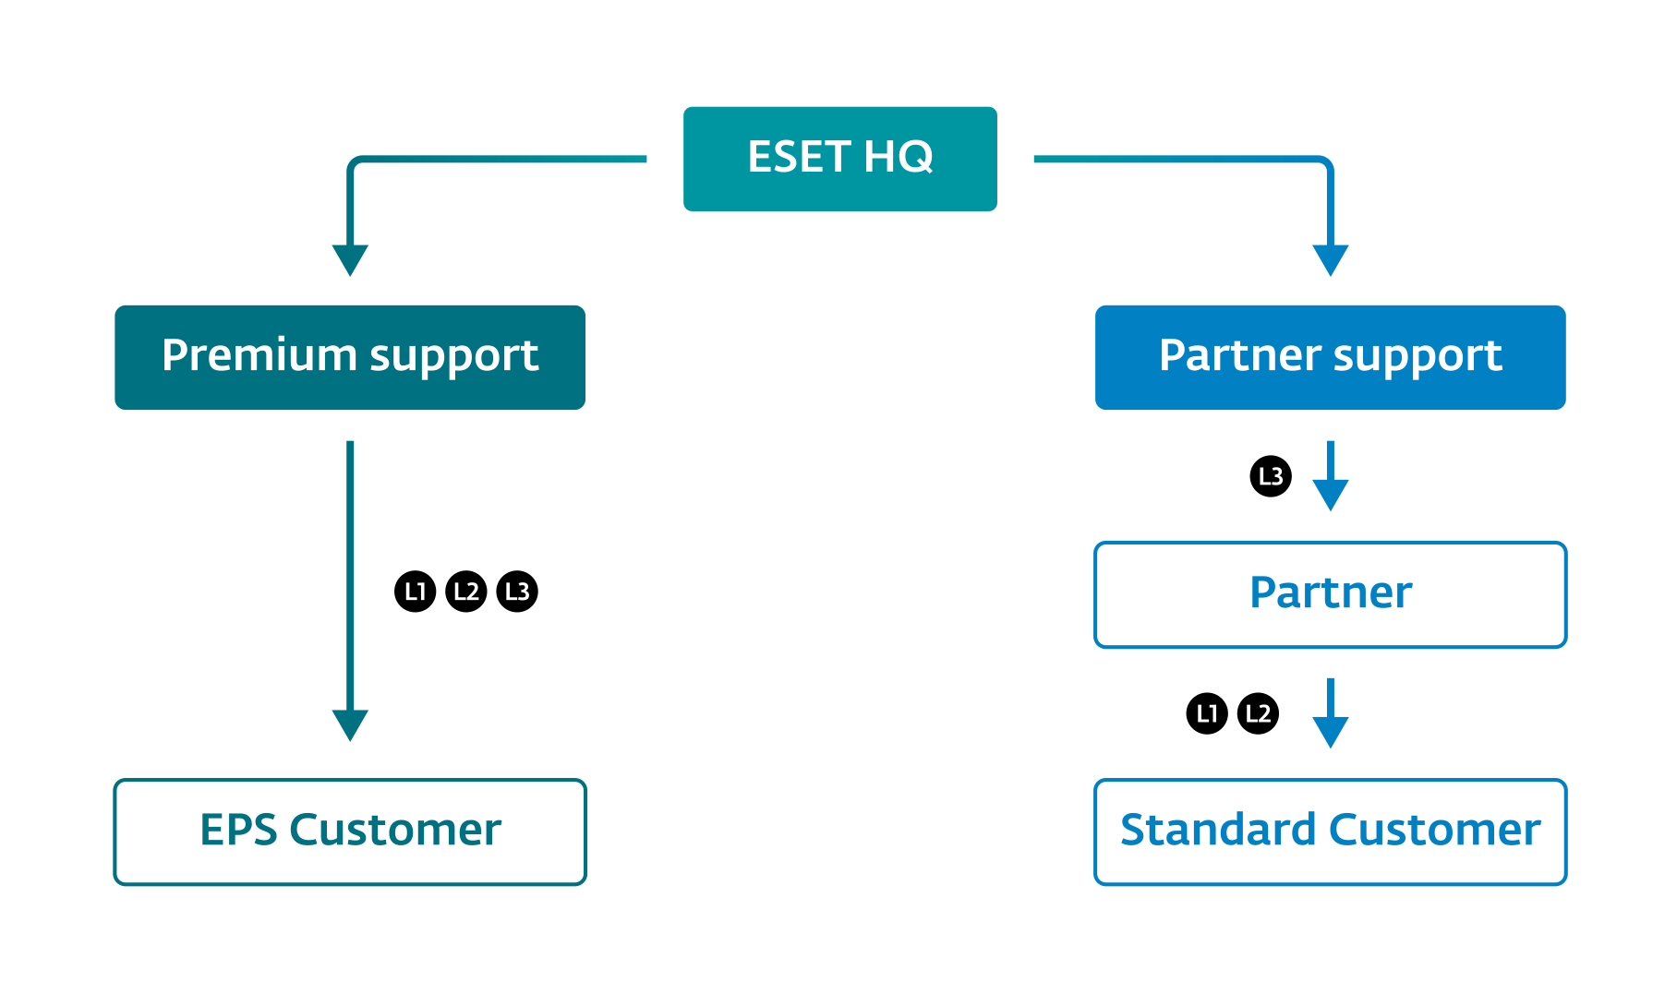The same Partners were usually responsible for providing their markets with technical support services as part of so-called “ESET Partner Support”. Nevertheless, a customer who purchased ESET Premium Support was automatically served as an EPSE account under ESET HQ jurisdiction and technical support was always provided by technical engineers directly from HQ in Bratislava.

Among the **major shortcomings** of our old delivery model were:

The **direct delivery** model described above, which was in place for ESET Premium Support until now, ultimately meant there were very limited scalability options. This was a serious limitation, considering ESET’s growing customer base. In combination with an indirect delivery model for Partner Support, our internal processes were significantly diverted.

**Fixed pricing, set at 17% of the cost of a business product license**, also represented a very rigid and old-fashioned approach to pricing, while our competitors price their services very dynamically – giving volume advantages to their Enterprise customers.

## The new ESET Premium Support Essential offering

At ESET HQ, we have scrutinized the aforementioned workings of the existing EPSE process and identified major improvements that will benefit both Partners and ESET HQ, from both a capacity-leveraging point of view and from a revenue-maximizing one. Our main focus when defining this new EPSE offering was on scalability and ESET uniformity across regions worldwide

## 1. Indirect delivery model

It is obvious that in recent years a great number of our Partners have invested in their employees' technical capabilities to a very high level. It does not matter much whether we are talking about training and certification in ESET products or other relevant IT training. Both have contributed to the fact that, as of 2020, we can state that a significant portion of our Partner network is now employing highly-trained professionals who are without doubt capable of executing the ESET Premium Support Essential service. Its exact processes, of course, will be outlined by ESET HQ in order to achieve EPSE consistency around the globe.

Including our partners in the service delivery model is beneficial for end-customers requiring on-site service delivery capabilities. And those are almost exclusively unique to local ESET representation.

Another reason for including Partners in the technical aspect of the EPSE service is the limited capacity for service delivery from ESET HQ. If we are honest with ourselves, ESET HQ is currently not capable of covering EPSE service delivery in all countries in which we sell our products. The technical specialists based at ESET HQ and dedicated to service delivery are, capacitywise, able to deliver only tens of EPSE customers a year. With regards to this fact, we feel that we are losing a big portion of revenue simply because we are currently not a service-oriented company. Therefore, including Partners’ trained staff into our service delivery model will definitely leverage the current overall resources available to both HQ and Partners. Using this deeper cooperation between HQ and Partners, we will multiply our mutual Premium Support Essential capacities, resulting in greater service coverage and revenue potential.

Now, ESET HQ will provide support only at Level 3 (Tier 3) to our Partners. Level 1 and Level 2 will be provided by our Partners directly to end-customers, without HQ’s involvement. Looking at the process aspect, the only tangible difference between standard support and EPSE will be the much shorter reaction times in favor of EPSE. These will have to observed by both ESET HQ and our Partners in order to fulfil the SLAs with our customers.

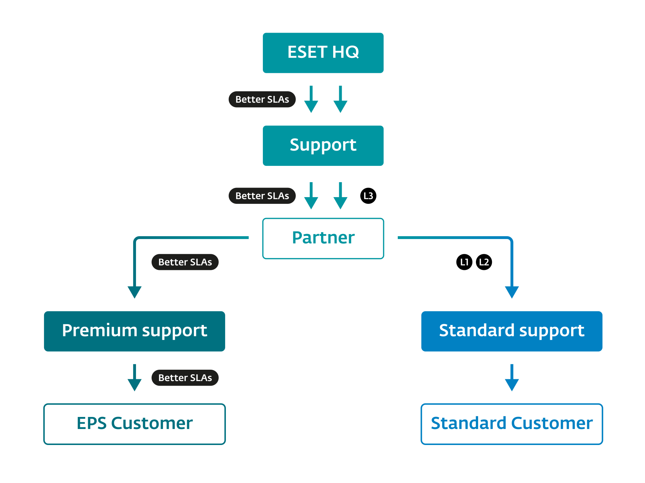The new service delivery model will look like this:

## 2. Comprehensive training plans for Partners’ staff

The new service delivery model, utilizing our Partner network to a greater extent, will definitely challenge us in terms of the consistency of the delivered service across different regions. Since our ultimate goal is to achieve the highest possible quality of service, delivered consistently, we have developed a comprehensive training plan for our partners’ professionals who will cover Tier 1 and Tier 2 Premium Support Essential tickets.

In the last chapter of this service bulletin we briefly suggest which trainings (either in ESET products or other related Microsoft trainings) HQ might require from each Partner’s Premium Support Essential professionals, regardless of their geographical location.

## 3. Tier-based pricing

To reflect the dynamic pricing models that make our solutions more cost-effective for Enterprises, we have completely rethought our old EPSE pricing model. The new offering features “fixed price per seat” pricing, which gradually declines according to which tier the customer falls under. We have categorized our customers into the following tiers: up to 499 seats, 500-999, 1000-1999, 2000-4999, 5000-9999, and 10000 and above. Discounts do not apply.

# ESET Premium Support Essential vs Standard Support

Below, the difference between EPSE and Standard Support is depicted.

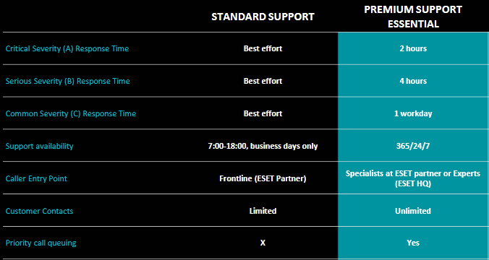

# Prerequisites and conditions for ESET Premium Support essential

* Only newly purchased (and deployed) ESET products are eligible for the EPSE service and should be a part of the overall solution (Products + Services) provided to customers
* Customers, with their environments and product licenses, have to be approved for the EPSE service by a Premium Support Specialist
* Technical issues (tickets) must be raised only within the related product license validity (timeframe) in order to benefit from the EPSE service: either 1, 2 or 3 years
* The service is primarily aimed at large Enterprise-grade customers or organizations with a complex infrastructure which warrants the costs of the service (exceptions must be discussed with HQ or local EPSE team)
* Customers must raise EPSE technical issues (tickets) via an official form/dedicated contact person at the local ESET Partner

# A screenshot of a map Description automatically generatedResponsibilities in the service delivery model

The diagram above depicts an ideal workflow for a customer support case raised within the ESET Premium Support service, with rows representing an “actor” or a person responsible for execution of a specific activity in the workflow. The goal of this diagram is to describe a sequence of sub-activities that leads to a successful, by-the-book resolution of technical issues that has arisen from using ESET business products and was in turn reported through the EPSE service. For the sake of simplicity, we will further describe the ideal flow of a technical support case (indicated by green arrows) without any change requests or inconsistencies which may occur along the way.

The **ESET Premium Support Essential** process begins with a customer identifying a technical flaw or a behavior that contradicts the one described in the product documentation of an ESET business product. For this product a valid EPSE license needs to be purchased. The customer immediately contacts his dedicated point of contact for the EPSE service at the relevant ESET Partner site.

Provided a ticket for this particular issue (with this particular customer) does not yet exist, the Premium Support Specialist (PSS) creates a new ticket on the customer’s behalf. If the PSS at the Partner is unable to resolve the issue by Tier1 / Tier2 means, he/she forwards the issue to ESET HQ (Tier 3 support) by creating a parallel support case. Irrespective of whether the partner is integrated via TSI or Salesforce, a parallel case reaches ESET HQ Tier 3 support.

For illustrative purposes, let’s assume that the Tier 3 PSS at ESET HQ is able to analyze the issue and provide a satisfactory solution/fix to the customer problem. At this stage, the status of the EPSE ticket is “Solving“. If the partner’s PSS verifies ESET HQ’s proposed resolution and is fully aligned with it (and requires no additional information from HQ), he/she closes the ticket by transferring it to “Resolved“ status. The customer is then informed by the Partner PSS about how his/her ticket was resolved and what actions to take in order to prevent the issue from re-occurring.

Of course, the example above follows an ideal workflow, including both L1/L2 and L3 support levels. Looking at the diagram, one can observes that there are also numerous alternative scenarios when it comes to EPSE service delivery:

* The technical ticket might get solved by Level 1 / Level 2 without ESET HQ assistance
* The ticket might, after analysis, be regarded as non-technical and therefore “Invalid”
* The ticket might be incomplete and might, after creation, require additional information from the customer
* Etc.

All possible scenarios/ workflows are covered in the diagram.

# List of products eligible for for ESET Premium Support essential

*As of June 1, 2020*

|  |  |
| --- | --- |
| ESET Cloud Administrator | ESET Full Disk Encryption |
| ESET Cloud Office Security* | ESET Full Disk Encryption for ECA |
| ESET Endpoint Antivirus for Linux | ESET Gateway Security for Linux |
| ESET Endpoint Antivirus for Mac OS X | ESET Mail Security for IBM Lotus Domino |
| ESET Endpoint Antivirus for Windows | ESET Mail Security for Linux |
| ESET Endpoint Encryption | ESET Mail Security for Microsoft Exchange Server |
| ESET Endpoint Security for Android | ESET Secure Authentication |
| ESET Endpoint Security for Mac OS X | ESET Security for Microsoft SharePoint |
| ESET Endpoint Security for Windows | ESET Security for Microsoft SharePoint Server |
| ESET Enterprise Inspector | ESET Security Management Center |
| ESET File Security for Linux | ESET Virtualization Security |
| ESET File Security for Microsoft Windows Server | ESET Security Management Center Cloud* |

* not yet released

Since ESET’s product portfolio is dynamic and our offering may change over time, it is strongly advised to always verify the list of products eligible for the EPSE service against our [End Of Life policy (EOL)](https://support.eset.com/en/kb3592-is-my-eset-product-supported-eset-end-of-life-policy-business-products). The list of products in the above table reflects our current business products offering, but to obtain fresh information regarding supported versions, always visit our EOL website.

# Human resources requirements for successful delivery

The goal of the ESET Premium Support Essential service is to provide the means for important customers to raise support requests within prioritized channels and under better SLAs. The environments of such customers should be already certified, as ideally the ESET Deployment & Upgrade service should already have been used. But that is not a must: customers are eligible for the EPSE also as a standalone service for environments where customers have deployed ESET products themselves.

ESET Premium Support Specialists (PSS) are Technical Support Engineers (or similar) who are eligible for this task and can introduce our best practices to customers based on their vast experience of solving customers’ technical issues. The PSSs are experts on several products based on in-depth knowledge from several years of experience (ideally) with ESET products on a technical position. They primarily take care of tasks according to their expertise but have also a good knowledge of other products. They deliver a high quality of work within their expertise and there is no need to frequently verify the outcomes of their work. They demonstrate very high reliability and full autonomy. They keep up to date on trends, new tools and ESET products. The PSS comes up with innovative ideas and solutions to problems, as well as with proposals for optimization of existing processes and systems, and suggestions to implement new tools and technologies. The PSS must cooperate and communicate with customers and other teams effectively, which requires very good communication skills and an ability to work in complex environments. In addition, each PSS should:

* Know and properly use all the tools and processes relevant for the tasks
* Prepare testing environments
* Reproduce reported issues and cooperate with ESET HQ while searching for solutions
* Provide remote assistance while troubleshooting if needed
* Perform conceptual, systematic, creative and methodical activities
* Suggest improvements to the services guides and processes
* Propose solutions and execute them in customers’ environments
* Manage projects related to services (per customers, tracking the related activities)
* Plan service provision by using existing systems

To reach global consistency in quality assurance of service delivery towards customers, ESET HQ requires the following certifications to be fulfilled by Partners’ PSS staff according to the Tier/ Level they aspire for:

### Tier 1/ Level 1 Premium Support Specialist

|  |  |
| --- | --- |
| Course Code | Course Name |
| HQ-TT | ETT | ESET Technologies Training |
| HQ-POT | EPOT | ESET Product Overview Training (Business part only) |
| HQ-EES | EES01 | ESET Endpoint Security Training* |
| HQ-ESMC_7 | ESMC01 | ESET Security Management Center Basic Training |
| HQ-ESMC_7-2 | ESMC02| ESET Security Management Center Advanced Training |
| HQ-TSS | TS01 | ESET Technical Support Training |

*The training is not yet available

### Tier 2/ Level 2 Premium Support Specialist

Furthermore, to properly support other ESET products, we recommend that the PSS also certify themselves to those products (if certification is available) besides their already existing PSS certification. We also recommend acquiring any relevant third-party certifications on the following topics: networking basics, database fundamentals, Windows servers.